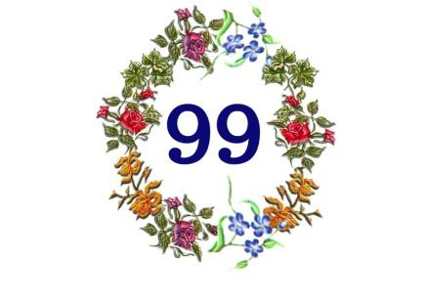

PRINCIPAL’S MESSAGE

1st April 2017! We are stepping into our 100th year with much pride, confidence and a thankful heart.

By God’s bountiful grace The Mama School has stood the test of times, seeing generations of daughters coming in and passing out through its portals.

Considering today’s competitive times, it is the School’s constant endeavour not only to equip our students with academic knowledge but also develop their personality holistically through various co-curriculars so that they can make a place for themselves in society and confidently face any challenge in life.

This year the Old Girls’ Association (OGA) was revived with its dynamic Managing Committee successfully hosting its first ‘Meet & Greet’ get together. We look forward to seeing more and more Ex-mamaians bonding at OGA’s future events.

It will also give us immense pleasure if our Ex-mamaians get in touch with School to share their success stories for our 100th Anniversary commemorative souvenir that shall be brought out.

May ‘God lead us onward, be ever at our side’ --- School Song

Mrs. F. Tampal
April 1, 2017.

